

**Instructions for the website of the FSC 2024**

1. Enter the website www.formulastudent.com.cn to enter the official website of the Fomula Student of China. It is recommended to use the Microsoft Edge browser (the browser has its own page translation function)

2. Enter the official website interface of the Fomula Student of China, and click the icon in the upper right corner to enter the login interface

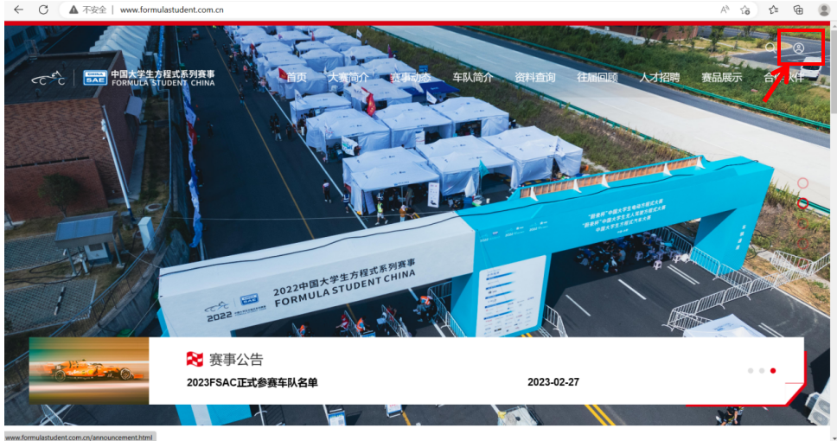

3.Select the team in the login interface, enter E-MAIL and password, and then click the login button (take Moscow State Bauman University of Technology as an example)

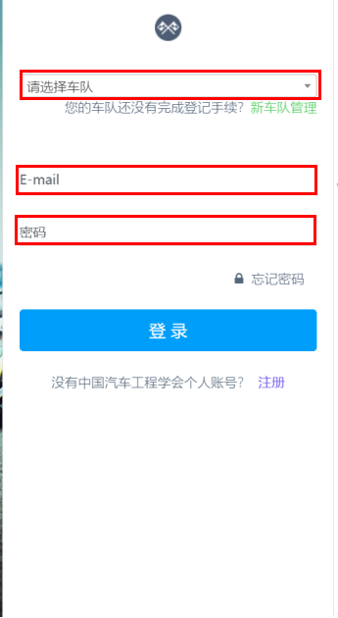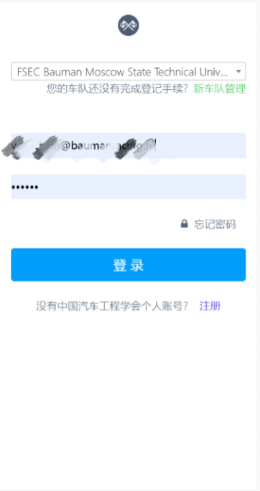

4.After logging in, enter the main page of the team and select the current year of the competition at the bottom. The green button(编辑名单) is "Edit the list" and the yellow button（上传赛事文件） is "Upload the competition file". Click the yellow button to upload the files required for the competition

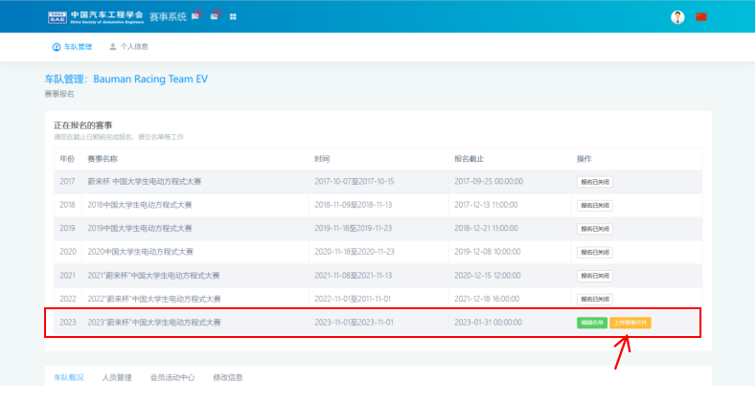

5.Enter the event file upload interface. In addition to the withdrawal application（退赛申请）, a total of 15 event files need to be submitted during the entire season

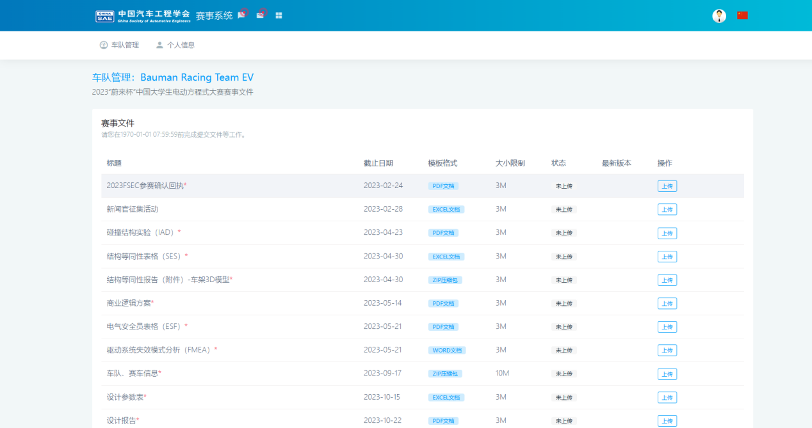

6.Take the 2023FSEC entry confirmation receipt as an example, click the blue icon under the "template format（模板格式）" to open the template file, and the blue icon also indicates the format requirements of the document you submitted (such as pdf, excel, zip, etc.)

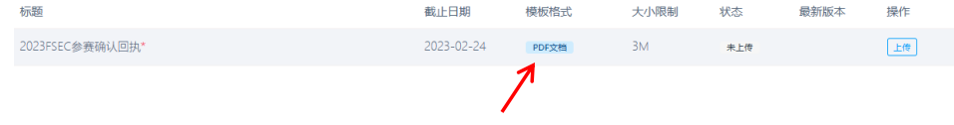

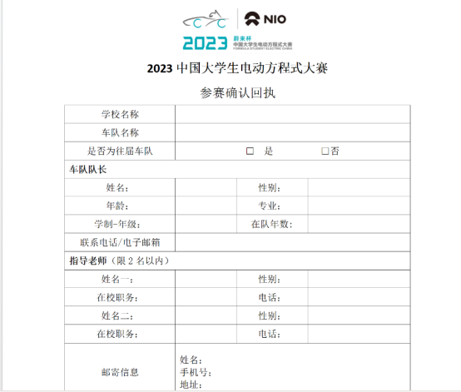

1. In the event file upload interface, click the "Upload（上传）" button on the right to submit the event file

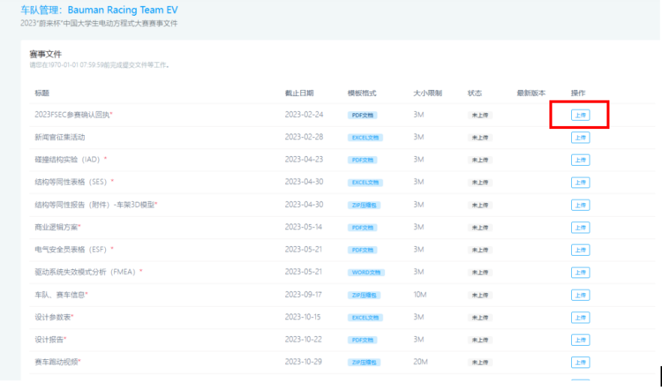

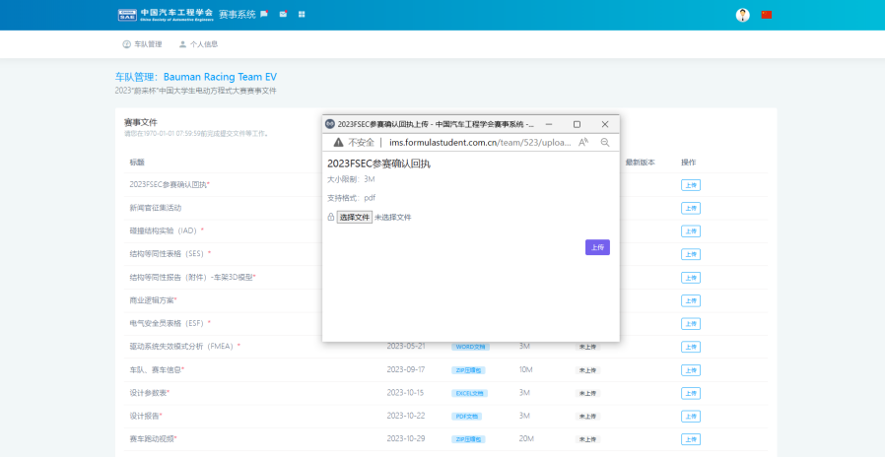

8. Click "Select File（选择文件）", select the file to be submitted in the computer, and then click the purple "Upload（上传）" button. Note: The file must meet the file format required by the template.

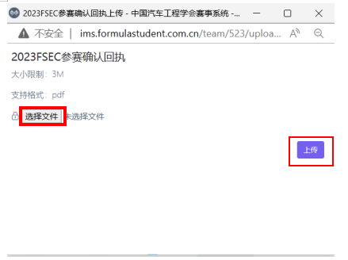

9.After uploading successfully, a prompt interface appears, and click “OK（确定）”

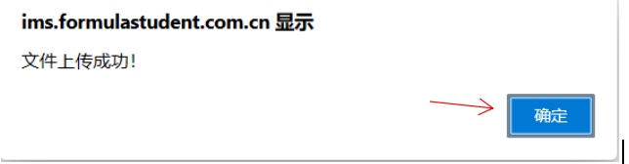

10.Refresh the interface after uploading, and the file status will change to "pending approval（待审核）"

